**Date:18-01-2025**

**To ,**

**Billa Nasaraiah**

2-199/1, Amani Jammala Madaka  
Zammalamadaka, Guntur District  
Andhra Pradesh, 522426

**Subject: Internship Offer**

Dear Nasaraiah,

With reference to your interview with us dated 16th January, 2025, we are pleased to offer you the Internship of “**Python Developer**” during this internship, you are going to be reporting to the CEO.

It will be an unpaid internship program for the period of 2 months starting from 20.01.2025 to 20.03.2025 to help you advance your knowledge and abilities under the supervision of professionals, with the following terms & conditions:-

* Your work schedule isfrom Monday-Saturday from 09:30 am to 6:30 pm. However, the nature of work may require some variation and extension of days or time.
* Each intern is required to put in at least eight hours of work per day. In case of late entry he/she is required to stay back & complete 8 hours of work excluding break.
* You are allowed to take a total of 4 leaves (2 CL + 2 SL) in a two month period, with the prior approval of your reporting manager.
* Emergency leaves can only be availed if an intern is unable to attend work due to some accident, illness or injury occurred to his/her immediate (blood relation) family member and should notify his/her manager as soon as possible.
* There will be direct termination of the internship when you constantly miss three or more days of work without notification.

This is an internship offer, valid only for 2 months and after successful completion of your Internship you will be awarded with the certificate.

During the course of your internship, you might have access to confidential information and trade secrets of **OZRIT**. By signing this offer, you agree to keep such information confidential and abstain from using it for personal gains or divulging it to any external entities, if failure to do so then company may take necessary actions as required.

At the end of your internship, you also agree to return any equipment, documents or other company property issued to you by the **OZRIT**.

Your acceptance to this offer shows your acknowledgement of the fact that this is not an offer for full-time employment and it does not guarantee a job offer upon completion.

### **Documents Required on the Date of Joining:**

1. Certificates supporting your **educational qualifications**, along with mark sheets
2. **Schooling Certificate (SSC/ICSE)** or **Birth Certificate** as proof of age
3. **Course Certificate**, if applicable

*Welcome on-board!*

With best wishes,

**For Ozrit AI Solutions Pvt.Ltd**

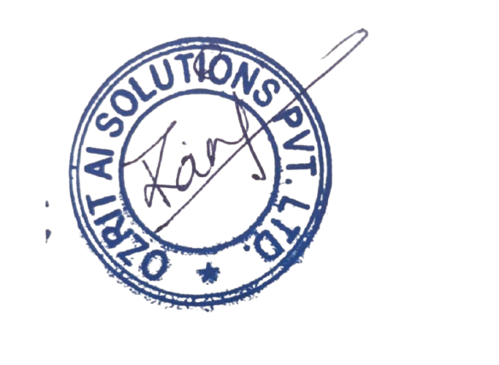

###### **Rani Kumari**

**HR & Admin Executive**

I accept this letter and the above terms and conditions.

**Nasariah**